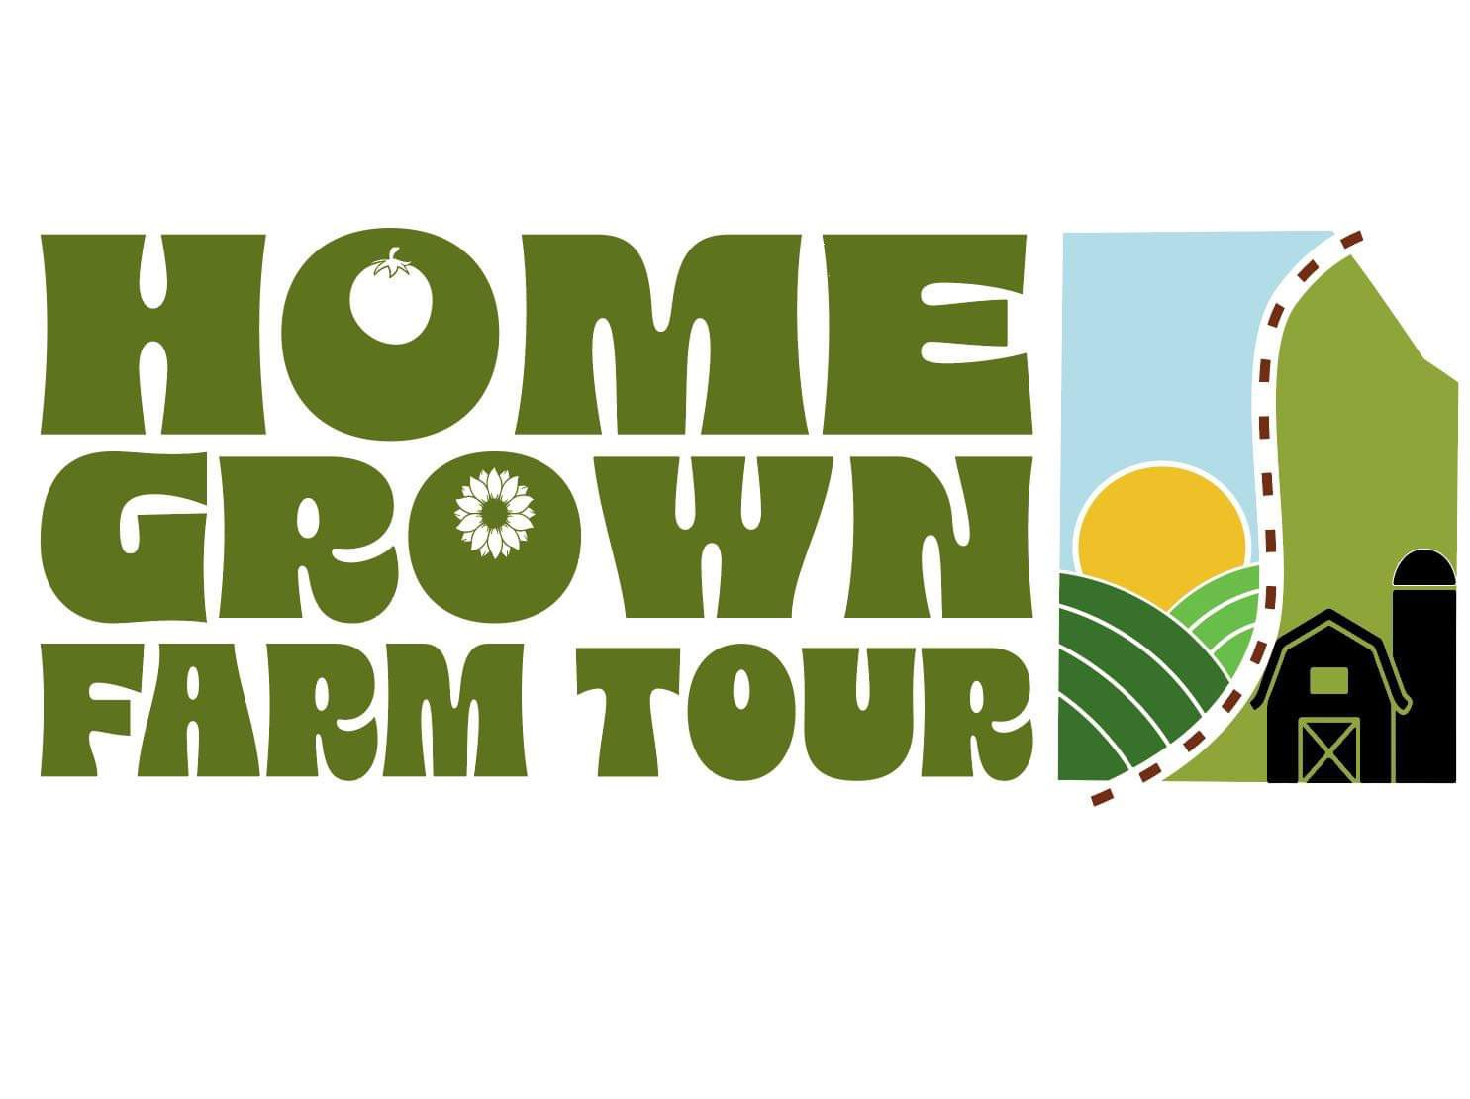

Dear Friend of Washington County:

The Washington County Chamber of Commerce is proud to present the Fourteenth Annual Washington County Farm Tour, Taste of Washington County Market Place and Field Dinner Picnic, which will be held Saturday, August 24th, 2024. Some of the county’s best farms, ranches, and growers will be featured in a self-guided tour and The Taste of Washington County Market Place will feature locally produced products. You have an opportunity to become a part of this event highlighting some of the best of our picturesque county and supporting our agriculture community through Scholarships, Grants and Public Relations.

The goal of the farm tour is to draw people from miles around to Washington County to see how food, plants and animals are grown in our pristine natural setting. It attracts people from all walks of life to look at Washington County for business opportunity, vacation property for recreation and relaxation or a country home to raise their family.

The money from advertising goes to publicize the Washington County Farm Tour through a brochure which highlights businesses countywide and to fund an agriculture scholarship and an agri-business grant, which will be presented during the Field Dinner. Please help us show others how attractive Washington County is by joining in our program with an advertisement highlighting your business or a sponsorship donation.

Advertising rates are as follows:
- $100 – Advertiser with a listing in annual brochure, location marked on brochure map and website listing from April 2024 to April 2025.
Sponsorship rates are as follows:
- $500 – Sponsorship with a listing on Venue Side of brochure, and website listing from April 2024 to April 2025, as well as listing on Signage at the Marketplace and Event Dinner.

See the attachment for the brochure from last year
If your organization is interest in advertising in our brochure, or sponsoring this event please complete the form on the back on this page.

Thank you for helping to improve business and tourism in our community!
Brochure Advertising or Sponsorship
Business/Organization Name:
Point of Contact Name:
Physical Address:

Contact Phone Number:
Email Address:

Artwork
We will email artwork to homegrownfarmtour@gmail.com
We would like no cost assistance in creating advertising artwork for the brochure

Payment
We will submit a check either in person or by mail payable to: Washington County Home Grown Farm Tour, Mailing address: 501 E. High St. Potosi MO 63664
We would like a payment link emailed to us at the below email for payment with debit/credit card. (A processing fee will apply) Email to send Payment link to:

We graciously appreciate your dedication to this community event. If you have any further question, or would like to find out how your organization can be a part of the August tour date, please email us at Homegrownfarmtour@gmail.com

